|  |  |  |
| --- | --- | --- |
| **Report IDM reference No.** | *2MN8N5* | **Version: 1.1** |

Final Report

on Deliverable

*MAT-1.3.2-T6-D1 Status Report on the Development of Ratcheting Rules (CCFE)*

|  |  |  |  |
| --- | --- | --- | --- |
|  | | **Deliverable-ID**[1] | *MAT-1.3.2-T6-D1* |
| **Work Package** | *MAT-EDDI* | **Date** |  |
| **Project Leader** | *Man minder Kalsey* | | |
|  | | | |
| **TS Title** | *Development of ratcheting design rules* | | |
| **TS Ref. No.** | *EDDI TS 1.3.2-T06* | **TS IDM-link** | [TS_1.3.2-T06](https://idm.euro-fusion.org/?uid=2CXFJ2&action=get_document) |
| **Task Owner** | *James Gardiner* | | |
| **RU(s)** | CCFE | | |

|  |  |
| --- | --- |
| **Report Review & Approval** | |
| **IDM role** | **Name(s)** |
| **Author** | *James Gardiner* |
| **Co-author(s)** |  |
| **Reviewer(s)** | *Manminder Kalsey, Mike Gorley* |
| **PMU Reviewer** | *Eberhard Diegele* |
| **Approver** | *Michael Rieth* |

|  |  |  |  |  |  |
| --- | --- | --- | --- | --- | --- |
| X | Study / Assessment |  | Procurement / Commissioning of Hardware |  | Industry |

|  |  |  |  |
| --- | --- | --- | --- |
|  | Use of Facility |  | Other *{please specify}* |

|  |
| --- |
| **Executive Summary** |
| This report introduces shakedown and ratcheting, discusses the limitations of the design codes that attempt to limit ratcheting and the even worse limitations of current plasticity models in Finite Element codes, then recommends a simpler, lower-bound, 2-step plasticity FE method that guarantees shakedown without any recoding, approximations or new theory. It is recommended that this method is introduced into design codes to fill the current void between inappropriate elastic and unsafe plastic cycling methods. |

|  |
| --- |
| **Comments** (shortcomings, deviations, etc.) |
|  |

**Table of Contents**

1 Summary 5

2 Introduction to Ratcheting 5

3 Problems With Current Ratcheting Design Methods 5

3.1 The 3Sm limit, Stress Linearisation and the Bree Diagram 5

3.2 Plastic-cycling Methods 7

3.3 Other Shakedown Methods 8

4 Elastic Unloading and the Melan Theorem 8

5 The Proposed 2-step Method 10

5.1 Introduction & Description 10

5.2 Comparisons with Theory 11

5.2.1 Thin Cylinder Bree Diagram with Constant and Proportional Pressure 11

5.2.2 Thin Cylinder Bree Diagram with Pressure and Axial Load 11

5.2.3 Thick Cylinder Shakedown Pressure and Bree Diagram 12

5.3 Comparisons With Other Methods 14

5.3.1 Plate with Hole 14

5.3.2 Dished End With Nozzle in Knuckle Region 15

5.4 Comparisons With Experiments 16

5.5 Testing with Multiple Materials 18

5.5.1 Results – pressure only 18

5.5.2 Results – thermal 19

5.6 Application to Cooling Panels 20

5.6.1 Engine Cooling Panel 20

5.6.2 Square-holed Fusion First Wall 21

5.6.3 DEMO First Wall, Water-cooled 22

6 Extending the 2-step Method 23

6.1 Temperature-dependent Yield Strength 23

6.2 Cyclic-softening Materials 23

6.3 Low-cycle Fatigue Regime 23

7 Discussion 24

8 Conclusions 25

8.1 Proposed Ratcheting Design Rules 25

8.1.1 Cyclic Hardening Materials 25

8.1.2 Cyclic Softening Materials 25

8.1.3 Brittle Materials 25

9 Recommendations for Further Work 26

10 References 26

*Figure 1: The progression of load cycling from purely elastic to ratcheting* 5

*Figure 2: Stress linearisation* 6

*Figure 3: Classic Bree diagram : pressurised thin cylinder with through-thickness thermal gradient* 6

*Figure 4: The Bauschinger effect* 7

*Figure 5: The 2-step shakedown method* 9

*Figure 6: 5-line diagram construction of shakedown factor* 10

Figure 7: Classic Bree diagrams for thin cylinder reconstructed via plasticity calcs. 11

Figure 8: Bree diagram for thin cylinder – with axial load 12

*Figure 9: Thick cylinder with b/a=3: model and mesh* 12

*Figure 10: Thick cylinder with b/a=3 : normally constrained faces and pressure loaded face (red)* 12

*Figure 11: Thick cylinder with b/a=3: Residual stress after unload* 13

Figure 12: Bree diagram for thick cylinder – Constant pressure loading 14

Figure 13: Plate-with-hole benchmark and associated mesh 14

Figure 14: Model for Dished end with nozzle in knuckle region 15

Figure 15: Dished end with nozzle in knuckle region: Residual stress after unload at p=0.44MPa 16

Figure 16:Oblique nozzle 5 benchmark model 16

*Figure 17: Oblique nozzle 6 benchmark model* 17

Figure 18: Oblique nozzle 5 benchmark residual stresses 17

Figure 19: Oblique nozzle 6 benchmark residual stresses. 18

Figure 20: Pipe intersection geometry 18

Figure 21: Residual stress with element sizes of 4mm and 2mm 19

Figure 22: Residual stress at yield for pressure only and thermal only loads 19

Figure 23: Comparison of 2-step method at different locations 20

Figure 24: Thermal and pressure loads for cooled panel 21

*Figure 25: Bree diagram for Vermaak cooling panel* 21

Figure 26: Fusion reactor first wall : thermal loads (left) and structural boundary conditions & loads 21

Figure 27: First wall – square hole: Bree diagram. 22

Figure 28: DEMO first wall : thermal (left) and structural boundary conditions/loads 22

**Abbreviations**

|  |  |
| --- | --- |
| *AFCEN* | *Association Française pour les règles de Conception, de construction et de surveillance en exploitation des matériels des Chaudières Electro Nucléaires* |
| *APDL* | *ANSYS Parametric Design Language* |
| *ASME* | *American Society of Mechanical Engineers* |
| *BB* | *Breeding Blanket* |
| *CCFE* | *Culham Centre for Fusion Energy, Great Britain (formerly UKAEA)* |
| *CEA* | *Commissariat à l'énergie atomique et aux énergies alternatives, France* |
| *DIV* | *Divertor* |
| *EDDI* | *Engineering Data & Design Integration* |
| *ENEA-CNR* | *Ente per le nuove tecnologie, l'energia e l’ambiente****-Consiglio Nazionale delle Ricerche***, *Italy* |
| *F4E* | *Fusion for Energy* |
| *IO* | *ITER Organisation* |
| *KIT* | *Karlsruhe Institute of Technology, Germany* |
| *MMF* | *Material Management Framework* |
| *MTA* | *Magyar Tudományos Akadémia, Hungary* |
| *NRG* | *Nuclear Research & Consultancy Group, Netherlands* |
| PMU | Project Management Unit |
| SAE | Safety & Environment |
| SDC | Structural Design Criteria |
| SDC-IC | Structural Design Criteria for In-Vessel Components |
| WBS | Work Breakdown Structure |

# Summary

This report introduces shakedown and ratcheting, discusses the limitations of the design codes that attempt to limit ratcheting and the even worse limitations of current plasticity models in Finite Element codes, then recommends a simpler, lower-bound, 2-step plasticity FE method that guarantees shakedown without any recoding, approximations or new theory. It is recommended that this method is introduced into design codes to fill the current void between inappropriate elastic and unsafe plastic cycling methods.

# Introduction to Ratcheting

Shakedown and ratcheting are best understood by looking at the following stress-strain diagrams of an elastic-perfectly plastic material under cyclic loading.

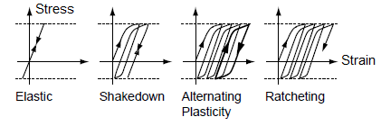

*Figure 1: The progression of load cycling from purely elastic to ratcheting*

The leftmost graph is a purely elastic state on loading and unloading which is the regime to use for brittle materials. The rightmost graph shows continuous and unremitting increase in plastic strain under repeated loading and this is called ratcheting. Failure does not occur by the ratcheting mechanism itself but by the effect of primary loads on the new geometry: For example imagine a pressurised cylinder where the radius increases in each cycle; with a constant volume so the wall becomes thinner until eventually bursting due to the pressure. The Low-cycle fatigue situation is also called alternating plasticity and is generally to be avoided. Shakedown is an observed phenomenon represented in the second graph whereby after an initial period of plastic growth, subsequent loading just causes elastic loading and unloading.

# Problems with Current Ratcheting Design Methods

## The 3Sm limit, Stress Linearisation and the Bree Diagram

Design code rules for the avoidance of ratcheting split into elastic and plastic methods. Elastic methods depend on limiting the stress range to twice yield (or 3Sm in ASME notation) but the raw stresses from a Finite Element model must be ‘linearised’ to remove the peak stresses and then ‘categorised’ int o Primary and Secondary stresses. This process, derived from thin shell theory is represented in *Figure 2* and has been standard practice for many years despite it being only strictly applicable in 2D shells and having many other limitations that are criticised in ref [xix] and elsewhere. The main problems are listed below:

* Radial and shear stresses should not have bending components so linearising them is illogical.
* For 3D problems a bending plane should really be used rather than a line but this is impractical.
* When a 3D line or point is used, different coordinate systems can make a 35% difference.
* It is often difficult to identify classification lines and quantify secondary stresses.
* It is only applicable to thin shells of revolution so linear stress may not be a good assumption.

Nowadays design codes avoid such arguments by not recommending the stress categorisation route for non-2D stress states (although some newer fatigue assessment methods actually rely on stress linearisation but that is a separate issue). Mostly this advice is ignored but sometimes peak stresses are used to avoid linearisation, which is an overly conservative approach.

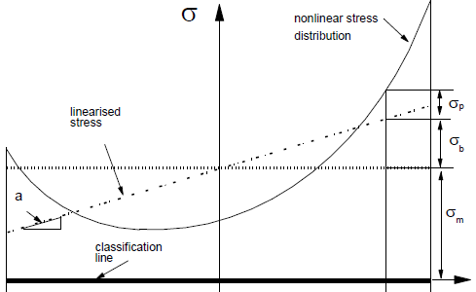

*Figure 2: Stress linearisation*

Use of the 3Sm limit is a necessary but not a sufficient condition. When thermal loads are present then the classical ‘Bree’ diagram, used in several design codes, presents shakedown limit lines for given pressure and thermal stress values or ratios. *Figure 3* shows the classical version of the Bree diagram on the right (with constant pressure) plus three others for different load histories, taken from reference [[2]]. The superimposed 3Sm limit is shown to be too conservative for two load-cases and can be unconservative for the other two.

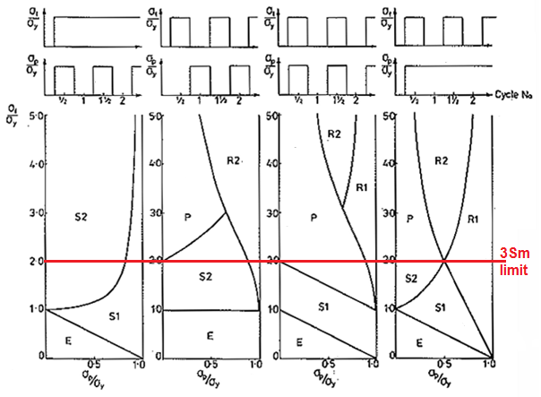

*Figure 3: Classic Bree diagram : pressurised thin cylinder with through-thickness thermal gradient*

Whilst the original Bree diagram has the shakedown region defined by shakedown after only the first half-cycle whilst the modern version allows repeated loading until linear elastic behaviour is achieved.

In the French RCC-MR design code an efficiency diagram is used for shakedown assessment, which is a reformed Bree diagram that has been tested for diverse geometries and loads – presumably (because RCC-MR doesn’t tell us) those common to fast-breeder reactors for which the code was originally created. Alas both types of diagram require stress categorisation after stress linearisation which limits them to 2D models; now very rare. So clearly the existing design code methods are all largely inappropriate for modern design work

## Plastic-cycling Methods

It is tempting nowadays to use Finite Element cyclic nonlinear analysis but unfortunately there is no suitable technique which can yet be relied upon. The simpler isotropic hardening model cannot even emulate the Bauschinger effect (*Figure 4*) whereby the range of the post-yield cycling is found to be still limited to twice yield, causing the compressive yield stress to change its value. Failure to allow for this effect allows unrestricted cyclic range increase which is unconservative.

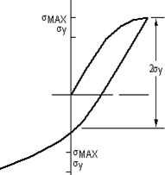

*Figure 4: The Bauschinger effect*

This Bauschinger effect should theoretically limit the benefit of strain-hardening for cyclic loading because it just moves the locus of yield in the failure diagram whilst leaving the stress range constant - unless the extent of the effect changes.

Multi-linear hardening models, while managing to emulate the Bauschinger effect, fail to produce ratcheting so are still useless [[3]] for ratcheting assessments. The nonlinear Chaboche method [[4]] can produce ratcheting but is limited by inconsistent and missing parameter data plus overly-conservative results [[5]]. The Chaboche method, furthermore, relies on a series of material properties that are difficult to derive and not available in design codes yet, and the last parameter must be a small, positive value (eg 0.1) or the structure will not shake down at all. Tests have also shown that the Chaboche method is often over-conservative and takes many cycles to exhibit shakedown so is computationally inefficient.

There are other constitutive methods in continual development but their results are erratic – eg working well for uniaxial loading and badly for biaxial loading or vice-versa. None of them are universally adequate or widely available and all of them require a great number of diverse material parameters that must be derived from only one or two tests. So there are many more unknowns than equations and optimisation routines are commonly used to derive and fine-tune these parameters.

Hardening is also dependent on strain-rate, prior loading, hold-times and load amplitude: Tests on type 304 stainless steel, usually presumed to be a strain-hardening material, actually show softening at stress amplitudes under 300MPa; still a high load [[6]].Neither should we use uniaxial test data to emulate a multiaxial stress state and we have not yet considered pre-existing residual stresses from manufacture.

In conclusion, for ratcheting assessments, it would be safer to use elastic-perfectly-plastic cycling as a lower bound method until much more proof testing has been done (although for high-cycle fatigue loading the situation is less pessimistic because predicted strain amplitudes are of higher accuracy than progressive strains [iv]).

## Other Shakedown Methods

There exist many papers in the literature recommending so-called ‘simple’ methods for shakedown load/factor identification. This shakedown factor always requires iterative analysis to find. Most of these papers deal with simple shapes and produce Bree diagrams. Some papers just rely on computational models to prove their analytical results but this appears to be invalid if there is not yet a computational technique capable of emulating shakedown or ratcheting correctly. Worse, most papers do not even describe the plastic cycling method that was used for validation – as if unaware that this is an important consideration.

Examples of ‘simple’ methods in the literature are elastic compensation [[7]] and the related linear matching method (LMM) [[8]], which attempt to define a plastic zone by a series of elastic analyses that modify the elastic modulus and the LISA [[9]] and deviatoric map[[10]] methods which each iterate to identify a self-equilibrating residual stress field. However none of these methods seem to offer a real benefit over elastic-plastic FE analysis; using similar yet even slower techniques that require extensive re-coding or post-processing that is usually geometry or loading dependent.

Owing to these, and other, disadvantages such alternative methods are not commonly used. The LMM method is an option for Abaqus but even its creators admit that it is not user-friendly and the observations in Appendix A of ref [[11]] about very serious problems in LMM do not inspire confidence. There is, furthermore, no utility in any method that calculates an upper bound to plastic shakedown as it is un-conservative by definition.

# Elastic Unloading and the Melan Theorem

We introduce here the relatively simple technique of performing an initial plastic loading and subtracting from the results a previously prepared elastic analysis representing the elastic unload. If the result leads to a residual stress value that is less than yield then the structure has shaken down.

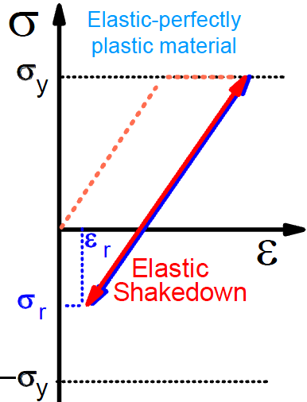

*Figure 5: The 2-step shakedown method*

By way of illustration, ref [[12]] used a 5-line construction on a 2-D (ie surface) Tresca or von-Mises yield locus at a nozzle/shell junction based on the Melan theorem. It is a 2D precursor to the 3D deviatoric map method previously mentioned.

Now two obvious corollaries of the widely accepted and validated lower-bound Melan shakedown theorem, taken from ref [[13]], are:

* If a first-order, linear-elastic, ideal-plastic model with associated flow law shakes down to linear-elastic behaviour under a cyclic action for any self-stress field then it will shake down for all stress-fields.
* Whether a first-order theory linear-elastic ideal-plastic model with associated flow law shakes down or not to linear-elastic behaviour under a cyclic action does not depend on the initial (residual) stress distribution.

Hence it is only necessary to identify a single valid residual stress-field that does not violate yield and we can ignore any pre-existing residual stresses in the structure.

Since we already know that the discontinuity (secondary) stress tensor must be self-equilibrating then, if we separate out the discontinuity stresses from the overall stresses, it is logical to extend a residual stress tensor from the origin, O, parallel to the discontinuity stress tensor until it hits the yield stress locus at point I and this then defines a self-equilibrating, residual stress state. Then by drawing a further elastic ‘unload’ line from I parallel to the original overall stress tensor up to the opposite yield locus, point H and also extending the original stress from O to the yield locus to get the first yield stress state, A, we can obtain a shakedown factor equal to IH/OA.The shakedown factor thus obtained was always found to be around the expected value (from tests) of around 2. This simple technique, while limited because it does not include thermal stresses or interior stresses, highlights the potential use of just a single cycle to determine shakedown.

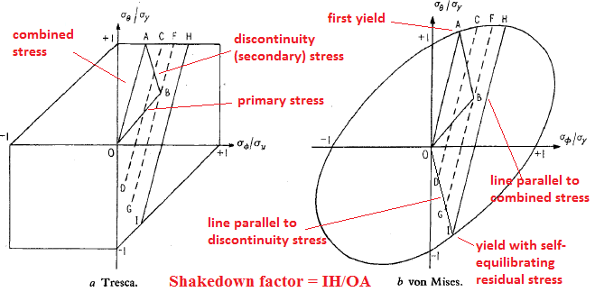

*Figure 6: 5-line diagram construction of shakedown factor*

# The Proposed 2-step Method

## Introduction & Description

Now ideally we want a shakedown assessment that uses Finite Element plasticity with the elastic-perfectly plastic material model and which is relatively quick. But we already know that if we can achieve a residual stress state that is less than yield upon the first elastic unload then we have proven shakedown by Melan’s lower bound theorem. This procedure requires only a 2-step analysis in FE codes but for some reason it is not referred to at all in design by analysis codes despite being much used in the pressure vessel literature. This method is applicable to all geometries with minimum computation and can take account of temperature dependence (see section 6):

First set an elastic perfectly-plastic material (ie no strain hardening) in the Finite Element setup at the required design temperature. Then perform a 2-step plastic analysis with all un-factored loads added on the first step followed by an elastic/plastic unload of the cyclic stresses on the second step. If, at the end of the second step, the residual stresses are less than yield then shakedown is achieved. If there are thermal transients then use the stress corresponding to the highest through thickness temperature difference for the first step and add the direct loads to it.

This method is similar to the methods used by both Abdalla et al., ref [[14]], and Muscat, ref [xvi], to prepare Bree diagrams via repeated iterations of a plastic analysis followed by subtraction of an elastic analysis for the same loading. Vermaak et al., ref [[15]], also used the Abdalla method for actively cooled thermo-structural panels subject to high heat fluxes on one side. But since there is no real need to construct a Bree diagram except as an academic exercise then there is no need for iteration. Neither is there a need for a separate elastic unload step instead of a 2nd plastic unload step which achieves the same objective without further post-processing.

This 2-step technique is allowed in the EN13445 design code by the statement, “the [shakedown] principle is fulfilled if the equivalent stress-concentration-free model shakes down to linear-elastic behaviour under the action cycles considered” (B.8.3.3), which must be carried out with a “linear-elastic ideal-plastic law with Mises' yield criterion” (B.7.4.4), and “all partial safety factors equal to 1” (B.8.3.1). We do not need to consider stress concentrations (re-entrant corners, radii, cracks) in the model because these stresses dissipate very locally and so have no effect on gross structural deformations. Unfortunately the ASME VIII code insists upon a minimum of 5 cycles for shakedown analysis but if the latter 4 cycles are forced to be in the elastic range then this requirement can be ignored.

For multiple load-cases there is a useful theorem mentioned in Annex A of Ref. [[16]] which states: “Each cyclic action for which the corresponding elastic stress field is enveloped by the envelope of the elastic stress field of a shakedown action is also a shakedown action”.

## Comparisons with Theory

### Thin Cylinder Bree Diagram with Constant and Proportional Pressure

As a proof test we can reconstruct two of the thin cylinder Bree diagrams previously presented in *Figure 3*. Taking inner radius=5 and thickness=1mm then it is found that the Pressure for first yield, Py=18MPa & the temperature for first yield, dTy =161°C.

Applying 0°C to the outside we vary the inside temperature and pressure to obtain the shakedown map. Figure 7 shows the resultant diagrams, where the x and y-axes are presented as ratios with Py and dTy as the respective denominators. These normalised axes are forced on us because the thermal and pressure contributions to stresses cannot be separated out in a finite element analysis.

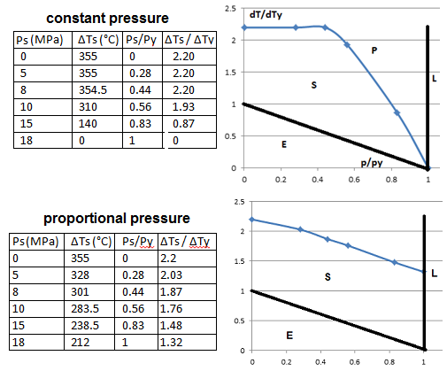

###### Figure 7: Classic Bree diagrams for thin cylinder reconstructed via plasticity calcs.

The comparison with *Figure 3* is good. The slight differences from the theoretical Bree graphs are due to use of the Von Mises yield criteria rather than Tresca.

### Thick Cylinder Shakedown Pressure and Bree Diagram

A thick cylinder with an arbitrary yield stress, Y=200MPa, Young’s modulus=200GPa, Poisson’s ratio=0.3 and elastic-perfectly-plastic stress/strain curve was created and run in Ansys. The model, mesh, boundary conditions and load are shown in Figure 7 where a=inner radius=5mm and b=outer radius=15mm.

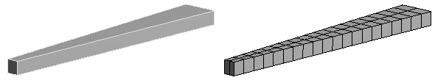

*Figure 9: Thick cylinder with b/a=3: model and mesh*

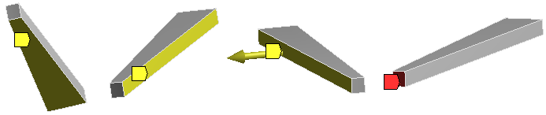

*Figure 10: Thick cylinder with b/a=3 : normally constrained faces and pressure loaded face (red)*

From base theory given in ref [[17]], b/a must be higher than 2.22 for a shakedown pressure less than the limit pressure so b/a was set to 3. By plastic analyses it was established that the Von Mises limit pressure is 234MPa which compares to the Tresca value of Pl = (Y/2)ln[(b/a)2] = 219MPa.

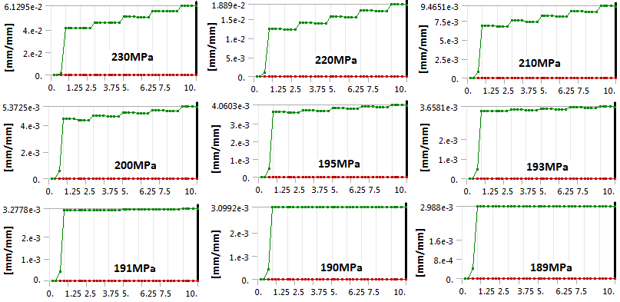

*Figure 9. Thick cylinder with b/a=3: Plastic strain at various pressures*

By Tresca the shakedown pressure should be Py= Y[1-(a/b)2]=177MPa, hence the Von Mises shakedown pressure is expected to be 177x234/219 = 189MPa. A load/unload cycle was carried out at different pressures and the shakedown pressure was indeed confirmed as 189MPa.

The von Mises stress after the first unload, ie the residual stress, is shown in *Figure 11*. As the maximum is less than yield we can say from just this one plot that the structure has shaken down. The next load produces a maximum stress of 197MPa, ie still slightly less than yield, so still elastic.

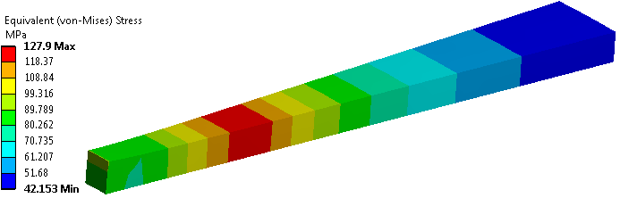

*Figure 11: Thick cylinder with b/a=3: Residual stress after unload*

It was also confirmed that the transition from failure bt collapse and failure by shakedown occurred when b/a=2.22.

As an interesting exercise, if we apply a thermal stress to the same thick cylinder as previously we can determine a Bree diagram for it with the 2-step method. This is shown in Figure 12 for the case of constant pressure. The x-axes are presented as p/py, where py=pressure for first yield = 102.5MPa. The y-axes are presented as dT/dTy, where dTy is the differential temperature for first yield = 124C. Plotting this data, we find the happy situation that for thick shells the ASME limit of 3Sm (ie twice yield) is a good approximation for thick cylinders under constant pressure regardless of the thermal stresses.

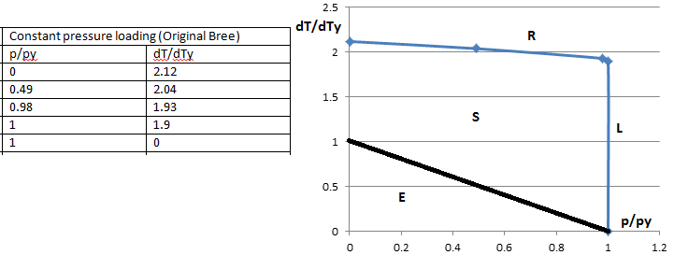

###### Figure 12: Bree diagram for thick cylinder – Constant pressure loading

## Comparisons with Other Methods

### Plate with Hole

Figure 13 shows a standard benchmark, much used in the pressure vessel literature. The mesh shown is actually a lot finer than it needs to be.

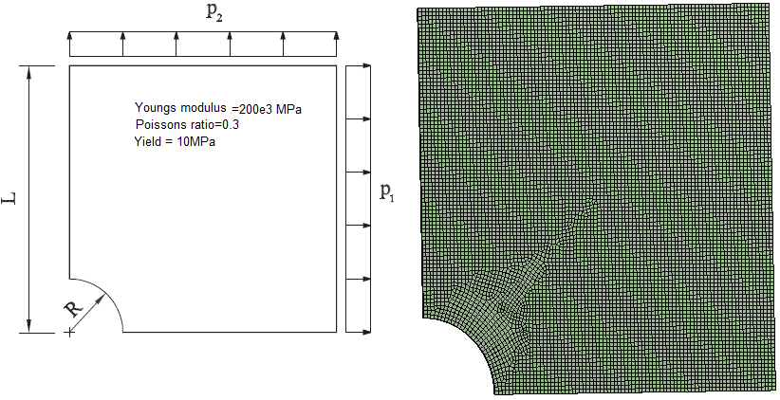

###### Figure 13: Plate-with-hole benchmark and associated mesh

Numerous investigators have produced results for this geometry by a variety of methods (see refs [[18]][[19]] for more detailed references). A comparison is presented below for the case where R/L=0.2 and p1=0. Here shakedown factor is defined as the pressure divided by yield strength. The literature constantly changes the definition with minimal explanatory notes, which seriously hinders replication.

|  |  |  |  |
| --- | --- | --- | --- |
| Method | Shakedown factor | Method | Shakedown factor |
| Belytschko | 0.571 | Silveira | 0.594 |
| Nguyen | 0.557 | Krabbenhoft et al. | 0.595 |
| Corradi *et al.* | 0.654 | Zouanin | 0.594 |
| Genna | 0.653 | Garcea *et al.* | 0.604/0.595 |
| Stein and Zhang | 0.624 | Tran et al. | 0.603/0.601 |
| Zhang *et al.* | 0.647 | Heitzer | 0.616 |
| Gross-Wedge | 0.614 | 2-step (current) | 0.613 |

The 2-step method is thus proven to be at least as good as any other proposed method and is close to the mean and median of the spread of values. With further analyses using proportional loading the 2-step method agrees with the graphical results in ref [xvi]. However the graphical results in ref [xvii] and ref [xvi] radically disagree with each other which may be due to differences in load cycling but the papers are too vague to resolve the matter.

### Dished End With Nozzle in Knuckle Region

The EN13445 Design By Analysis manual, ref [[20]] example 4, was recreated (see Figure 14) in order to compare the 2-step method with competing methods for a more practical example. It is a slightly unfair comparison because thin shell models were used in the manual compared to solid elements here and computation times were much longer when the manual was written. However it is a worthwhile comparison since these are methods recommended by a code committee and the advice has never been updated.

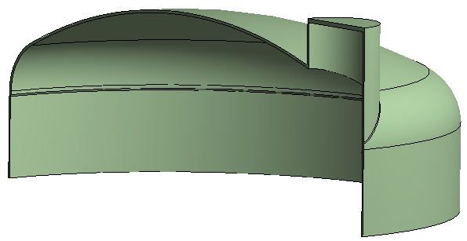

###### Figure 14: Model for Dished end with nozzle in knuckle region

Only two of the six verification groups attempted this analysis and they predicted shakedown pressures of 0.289, 0.375 and 0.271 by a series of bewildering assumptions, combinations, interpolations, fudge factors and complex load steps with pseudo stresses and strains. Ref [[21]] also attempted this sample geometry with the deviatoric-mapping method and predicted a factor of 0.504, which relies on estimating a self-equilibrating residual stress field and then applying yet another factor.

It seems then that the currently recommended alternative methods give wildly different results. Meanwhile the less approximate, easily replicable and hence far more believable 2-step method predicts 0.44 after convergence testing; ie within the spread of estimates.

Figure 15 shows the residual stresses after unloading which shows that maximum values are achieved in the same locations as the other assessments.

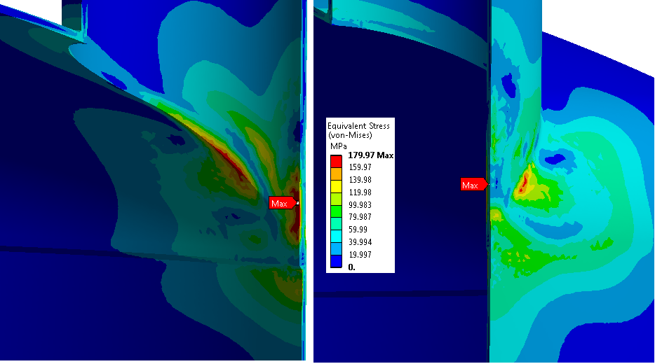

###### Figure 15: Dished end with nozzle in knuckle region: Residual stress after unload at p=0.44MPa

## Comparisons With Experiments

The verification examples in ref [[22]] of oblique heads in spherical shells are replicated here. The nozzle and head have different yield strengths (265MPa & 273MPa respectively) so split models were used with shared nodes at the material interface. Partial penetration welds were modelled as in the original tests. The mesh was refined to 3mm element size to a distance of 180mm from the centre portion during the convergence tests though a less fine mesh of 6mm elements also proved adequate.

The lower bound shakedown load (highest pressure where shakedown was achieved) from the test is 4.82MPa compared to 4.9MPa for the 2-step method. There is also a higher bound test value of 5.17MPa (first pressure where shakedown was not achieved). The difference is likely just an error spread since in the absence of thermal stresses these values should be the same.

The fillet weld sizes were guessed so the stress state there is not accurate. However shakedown was measured at the nozzle bore in the tests . It is notable that the LMM method used in ref [xxi] did not predict either the fillet weld stresses or a second plasticity region on the other side of the nozzle though it seems that they had full penetration welds which may explain this discrepancy. However the LMM lower bound shakedown load was still just 4.53MPa.

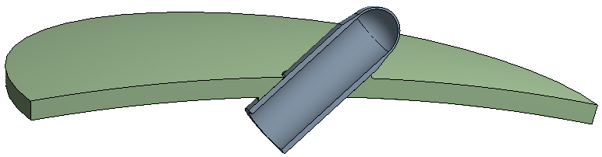

###### Figure 16:Oblique nozzle 5 benchmark model

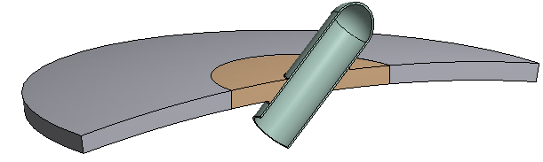

*Figure 17: Oblique nozzle 6 benchmark model*

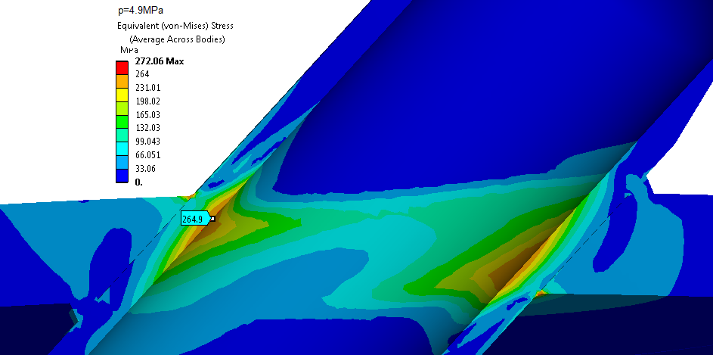

###### Figure 18: Oblique nozzle 5 benchmark residual stresses

The other model from ref [xxi] had a thinner pipe for which the lower and upper bounds of Shakedown pressure from the tests were 4.48MPa and 4.82MPa respectively whilst the 2-step analysis produced 4.22MPa. The LMM method, by contrast, produced 4.12MPa.

So we can echo the abstract of ref [xxi] and state that a comparison of the results shows that the 2-step method is capable of predicting accurate yet conservative limit loads and shakedown limits and add that it is demonstrably more accurate than the LMM method despite being far simpler.

###### 

###### Figure 19: Oblique nozzle 6 benchmark residual stresses.

## Testing with Multiple Materials

Although multiple materials were used in section 5.4, another benchmark test of a pipe Intersection from ref [[23]] is reproduced here (see Figure 20) in order to explore this issue in more detail.

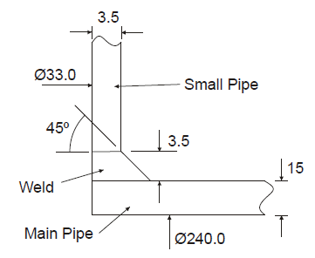

###### Figure 20: Pipe intersection geometry

Material properties for the 3 parts are given below:

|  |  |  |  |  |
| --- | --- | --- | --- | --- |
| Material | Youngs modulus GPa | Yield strength MPa | Poissons ratio | Coeff of ther. expansion |
| Small pipe: SA508 | 200 | 472 | 0.3 | 1.4e-5 |
| Weld: Inconel | 200 | 387.6 | 0.3 | 1.5e-5 |
| Main pipe: 316 | 200 | 220 | 0.3 | 1.8e-5 |

The three parts were split in Spaceclaim and topology was shared to allow nodes to match across the different materials. Symmetry restraints were used for 2 directions and the top of the small pipe was fixed vertically. Pressure was applied to the inside surfaces.

### Results – pressure only

With no thermal constraint, plasticity is achieved on the residual stress, ie the shakedown limit, at a pressure of 15.5MPa. Halving the default element size to 2mm did not change that result at all. So the 2-step procedure does not rely on dense or complex meshing procedures.

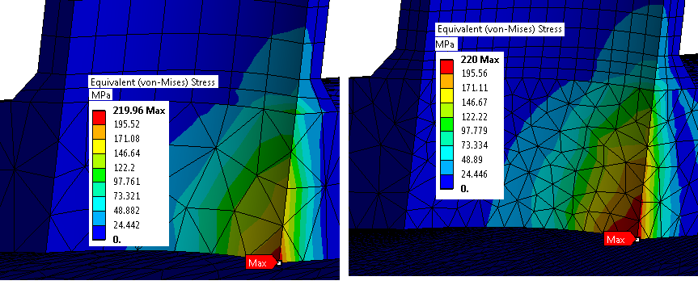

###### Figure 21: Residual stress with element sizes of 4mm and 2mm

### Results – thermal

The highest stress is at a different place for thermal stresses, though still at the thick cylinder bore. The first yield was achieved at a temperature difference of 70°C (20 outside and 90 inside). Other points on the shakedown curve came from selecting a pressure and iterating the inside temperature to create a achieve stress of yield.

However the maximum stress is at opposite sides of the opening for pressure and thermal loads. For the mixed pressure + thermal load the maximum stress is between these two locations, as shown in Figure 22:

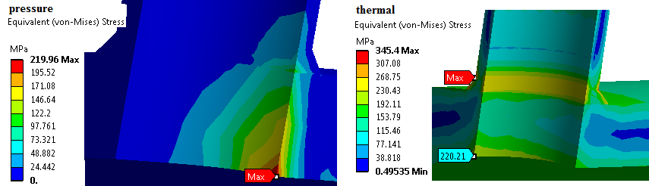

###### Figure 22: Residual stress at yield for pressure only and thermal only loads

Also you get a different graph for different locations. The difference between a Bree diagram for the vessel bore and the weld location are shown in Figure 23. The weld Bree diagram agrees with ref [xxii] but this highlights two potential problems for any automatic method that measures results at fixed locations.

|  |  |  |  |  |  |  |
| --- | --- | --- | --- | --- | --- | --- |
| Bree diagram at bore | | | | | | |
| p/py | 0 | 1.96 | 2.1 | 2.24 | 2.38 | 2.17 |
| dT/dTy | 1.17 | 1.04 | 1.02 | 1.0 | 0.92 | 0 |

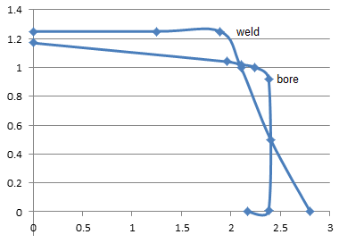

###### Figure 23: Comparison of 2-step method at different locations

## Application to Cooling Panels

### Engine Cooling Panel

Vermaak et al. [xiii] used the Abdalla et al. [xii] iterative 2-step scheme in order to construct a Bree diagram for an actively cooled panel for a propulsion system for a hypersonic vehicle, which is similar to a thermomechanical problem encountered in fusion reactor engineering. Unfortunately some boundary conditions and loadings were omitted form the document but an attempt at replication was made using suitable estimates.

Py=First yield pressure = 3.55MPa

ΔTy=First yield temperature drop = 171°C

While the general data trend is the same for the shakedown limit, there is a distinct difference between the Bree diagram achieved by the 2-step method described here and the results reported by Vermaak. On closer inspection this difference turned out to be entirely due to the fact that the location of the shakedown load moves from the edge to the centre as the loads change, which is a rather important design consideration.

So once again we see that automated methods can easily be unsafe because they preselect the stress assessment points rather than tracking their development and movements. Another, less important, difference arose because Vermaak used a theoretical value for Py that was 30% higher than the actual Finite Element derived value, thereby foreshortening the x-axis values.

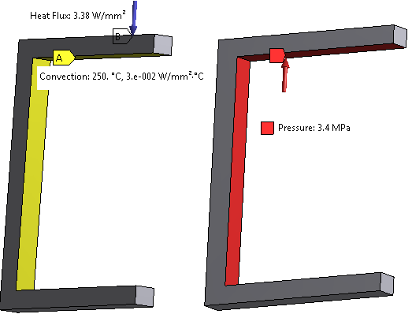

###### Figure 24: Thermal and pressure loads for cooled panel

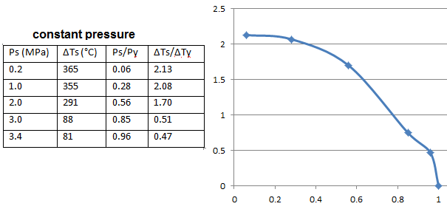

*Figure 25: Bree diagram for Vermaak cooling panel*

### Square-holed Fusion First Wall

Now we will try something that is closer to a fusion component; one version of a first wall, composed of type 316 stainless steel. This is taken from ref [[24]], where all properties are taken at 250°C, in particular the yield strength, Y=135MPa. The coolant pressure=8MPa. We need to apply a symmetry restraint in the x-directions and couple the x-displacements on the opposite faces which allows thermal expansion in the x-direction but prevents rotation.

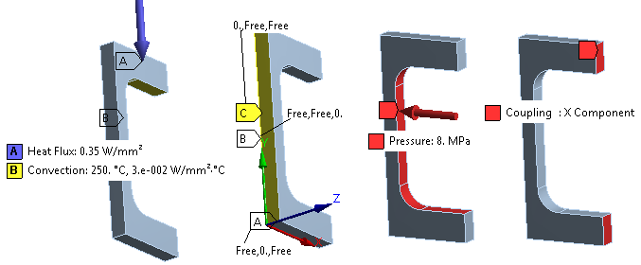

###### Figure 26: Fusion reactor first wall : thermal loads (left) and structural boundary conditions & loads

Py=9MPa & Wy=0.197W/mm2 -> dTy =(310-250) = 60ºC

Test results and a corresponding graph are shown in Figure 27.

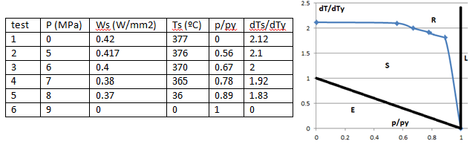

###### Figure 27: First wall – square hole: Bree diagram.

This diagram reconfirms that the thinner the part, the more the pressure dominates regardless of shape, and hence the less the shakedown factor of 2 (analogous to the 3Sm limit) is valid with increasing pressure.

### DEMO First Wall, Water-cooled

This is a cuboidal block with a circular tube welded into place in the interior. The material is Eurofer97 for both tube and block. This is only one option for the first wall and is not up to date.

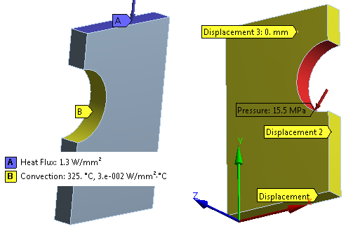

###### Figure 28: DEMO first wall : thermal (left) and structural boundary conditions/loads

From initial tests we find pressure for yield, Py=191MPa & the wall temperature difference for yield, dTy =575-390 = 185ºC measured at the top centre edge, which corresponds to a heat flux of 1.05W/mm2. At such a high first yield pressure it is unproductive to complete a Bree diagram so only a single thermal shakedown factor was calculated at the working pressure of 15.5MPa. The dT was limited by the maximum temperature allowable in the metal. Any softening or creep was ignored for this exercise. The typical pressure vessel-form shakedown factor of 2 (ref [xi]) was achieved.

|  |  |  |
| --- | --- | --- |
| dTy (ºC) | dTs (ºC) | dTs/dTy = shakedown factor |
| 185 | 836-461=375 | 2.03 |

# Extending the 2-step Method

## Temperature-dependent Yield Strength

Most Finite element codes allow the input of different yield strengths at different temperatures. So when using the 2-step method, instead of comparing the residual stress after unloading with the temperature-dependent yield strength, it will be easier to compare the accumulated plastic strain as demonstrated in *Figure 9*. This parameter is always positive so there can only be an increase in strain from step 1 to step 2 if the residual stress goes plastic, or zero increase if it remains elastic; hence demonstrating elastic shakedown.

## Cyclic-softening Materials

Cyclic softening is the loss of mechanical strength and the accompanying reduction in surface hardness which some hard materials show under low-cycle fatigue**.** From extensive testing of aluminium alloys, ref [[25]] tells us that cyclic softening;

* is not attributable to temperature change,
* like hardening, it takes place in the first few cycles and so does not affect high-cycle fatigue,
* can be reversed by subsequent monotonic strain so is not permanent,
* affects torsion elastic range more than tension elastic range,
* and may cause buckling to occur.

Also:

* Materials which show cyclic softening between cycles show normal hardening under both monotonic loading and within the cycles.
* Initial rate of softening increases with initial hardness and with the size of cycles; ie the smaller the hysteresis loop, the slower the softening.
* A model based on properties changing by time or strain-rate will not describe cyclic softening.

Note that softening can be considered as a partial removal of residual stresses induced during manufacture, ie a stress-relief: Soft materials become hard and hard materials become soft. Coffin and Tavernelli, ref [[26]], have shown that for materials hardened by pre-straining, softening occurs if the cyclic strain range is less than the prestrain and If the range is larger than the prestrain then the material will harden. If the range and the prestrain are equal then there will be no net change. Of course, as discussed earlier, the same material (eg the 304L) can exhibit cyclic hardening or softening depending on the cyclic stress range.

Ref [xxiv] also tells us that an elastic-perfectly plastic model can be used if yield stress is a decreasing function of the number of cycles (N) but there is no empirical formula – it requires a curve-fit of test-data. Alternatively the user can just do an elastic-perfectly plastic model with the yield stress in the softened, steady state, which will always be conservative.

## Low-cycle Fatigue Regime

Only the lower boundary of this portion of the Bree diagram (see *Figure 3*), otherwise called plastic shakedown, is predictable by the 2-step method. Several researchers pretend that the upper-bound theorem of Koiter is useful for defining the upper boundary; ie between low-cycle fatigue and ratcheting, but obviously an upper bound limit is unsafe by definition so methods based on that line of argument have little practical value.

However, it appears that the kinematic hardening model can estimate a low-cycle fatigue limit but more important than that is the observation that this limit is not essentially different from the perfectly-plastic model as reported in ref [[27]]. So once again the simpler, less-controversial material model is found to be adequate.

In ref [[28]] it is asserted that R6-style failure assessment diagrams (FAD) can be constructed by a similar 2-step technique; the main difference being that step 2 is a simple negative elastic unload. If true we can extend the usefulness of the2-step technique into the low-cycle fatigue range which is where high temperature, low-pressure systems (such as fusion reactor components) fall.

# Discussion

The main simplification uncertainties made in shakedown assessment methods (often forced on us by inadequate design codes) and repeated in much of the literature, are as follows:

1. Using uniaxial test data for multiaxial loading.
2. Use of monotonic yield curves rather than cyclic curves.
3. Stress linearisation and categorisation for complex 3D situations.
4. Assuming that the 3Sm limit is a sufficient criterion.
5. Use of Bree diagram for inappropriate geometries ; ie anything other than a thin cylinder.
6. Ignoring the Bauschinger effect; eg in the use of isotropic hardening.
7. Use of FEA with a hardening model which cannot produce ratcheting.
8. Use of FEA with a hardening model which cannot produce shakedown.
9. Ignoring cyclic softening.
10. Ignoring the assumptions inherent in obtaining Chaboche parameters.
11. Using iterative elastic methods in the outdated belief that it is quicker than plastic methods.
12. Unnecessary iterations to find limit loads and shakedown factors of limited use.

However by returning to the first principles and taking into account the real needs of the industry stress analyst rather than the academic, it has been demonstrated here that a simple lower-bound 2-step plastic analysis with an elastic-perfectly-plastic material model can be used to prove a design and eliminate all of these uncertainties except No. 1 (multiaxial loading). So not perfect, but quite close!

In addition the 2-step shakedown method was used to demonstrate that a Bree diagram can be easily constructed for arbitrary geometries quickly and with no extra coding, though that facility is just a bonus for use in academic investigations and is not actually required or recommended for design reports.

The 2-step technique can easily take account of yield strength variance with temperature and is also easily adaptable to components with multiple materials – even the functionally graded materials proposed for DEMO.

While it is argued in this report that strain-hardening should not be so important in cyclic loading due to the Bauschinger effect limiting the stress range to twice the elastic limit – which seems obvious , that notion is disputed by ref [xxvi] which produces a real difference in shakedown value for hardening materials. Whether this is a real finding or just due to the inappropriate upper bound algorithm used would require laboratory testing to verify.

However adapting this 2-step technique to stress softening is probably more important and that would probably require an increase to perhaps 10 steps plus an equation for cyclic yield stress which varies with the number of cycles. Note that stress softening cannot be simulated by currently available techniques because of the difficulty in combining intra-cycle strain hardening with inter-cycle strain softening, so any new technique is welcome.

Note that irradiation actually increases brittleness so reliance on extended plasticity is perhaps unwise and hence limiting plasticity to a single cycle is a safe assumption - all else being equal. It is possible that irradiation-induced hardening and cyclic softening may cancel each other out but, again, testing is required to find out.

# Conclusions

* We should avoid elastic analysis as it is dependent on stress linearisation and categorisation as it is both unjustifiable and potentially unsafe for most components and loading situations.
* We should also avoid using any newer hardening Finite Element material models other than elastic-perfectly plastic for design and stress assessment until they are proven reliable and safe.
* Meantime we can easily assess shakedown/ratcheting by a 2-step, load-unload cycle and checking that residual stresses are less than yield or that they don’t increase the overall plastic strain. This disarmingly simple technique has been well proven in this report and requires no additional coding or approximations unlike the many alternatives proposed in the pressure vessel literature.

## Proposed Ratcheting Design Rules

Until further work is carried out to verify better procedures, the rules below should be followed when using the 2-step shakedown analysis.

### Cyclic Hardening Materials

While the yield strength increases for cyclic hardening the Bauschinger effect shows that the stress range is still within the twice yield range. Therefore there should (theoretically) be no large advantage gained from hardening and so an elastic-perfectly plastic model should still be used with the proof stress substituted for the yield stress as appropriate.

### Cyclic Softening Materials

Cyclic softening materials are more common than is generally thought: Any material that has been cold-worked will soften at higher temperatures and many common materials will weaken (ie reduce yield strength) after the initial load cycle. Also many metals appear to strain-harden on the 1st loading only to subsequently soften with further cycling. The safe way to analyse this effect with the 2-step approach is to use the cyclically-softened proof stress as the material yield strength.

### Brittle Materials

Do not do any shakedown assessment! Brittle materials do not exhibit plasticity so theoretically cannot ratchet or shakedown. So they must not be allowed to go beyond the elastic limit as they will crack. Use the maximum principal stress value for assessments because the Von-Mises & Tresca criteria are invalid for brittle materials.

# Recommendations for Further Work

* Investigate more advanced strain-hardening material models, in particular any suitable for cyclic softening and with reduced material parameters.
* Identify a preferred model for different situations, to be used where less conservatism is justified.
* Investigate the cyclic-softening methods of section 8.1.2 and section 6.2 and also with a verified plastic cycling method. Unfortunately most shakedown testing has been done with a strain-hardening in mind but we can use the softened-state CuCrZr and Copper Chaboche material properties given in ref [[29]].
* More investigation is recommended to find out if uniaxial test data are truly suitable for multiaxial loading.
* The extension of the method, as discussed in section 6.3, warrants further investigation.
* A separation of ratcheting from alternating plasticity (low-cycle fatigue) would be useful.

# References

1. One *Deliverable Report* shall be submitted for each deliverable e.g. Study Report, Commissioning Report, Final Assessment Report, Technical Acceptance Report, Procurement Report, etc.
2. [] D. N. Moreton & H. W. Ng, “The extension and verification of the Bree diagram”, Structural Mechanics in Reactor technology, Vol L, 1981
3. [] Rezaiee-Pajand & Sinaie, “On the calibration of the Chaboche hardening model and a modified hardening rule for uniaxial ratcheting prediction”, International journal of solids and structures 46, pp3009-3017, 2009
4. [] J. L. Chaboche, “Constitutive equations for cyclic plasticity and cyclic viscoplasticity”, International Journal of Plasticity 5, pp247-302, 1989
5. [] K. Steingrimsdottir, “Analysis of plastic deformation in components subjected to cyclic loading”, Inspecta research report, June 2009.
6. [] Dahlberg & Segle, “Evaluation of models for cyclic plastic deformation – a literature study”, SSM (Swedish Radiation Safety Authority), Dec. 2010
7. [] Hamilton et al., “A simple upper bound method for calculating approximate shakedown loads”, ASME journal of Pressure Vessel technology 120, May 1998
8. [] Chen H.F., “A direct method on the evaluation of the ratchet limit”, Journal of Pressure Vessel Technology 132, 2010
9. [] Staat et al., “Direct finite element route for design-by-analysis of pressure components”, Int. Journal of Pressure Vessels and Piping 82, pp61-67, 2004
10. [] J. L. Zeman & R. Priess, “The deviatoric map – a simple tool in design by analysis”, International journal of Pressure Vessels and Piping, Vol 76, Issue 6, pp339-344.
11. [] A. Jappy, “A constitutively Consistent Lower bound, Direct Shakedown and Ratchet method”, PhD thesis University of Strathclyde, 2014.
12. [] MacFarlane & Findlay, “A simple Technique for Calculating Shakedown Loads in Pressure Vessels”, Proceedings of the Institute of Mechanical Engineers 186, 1972
13. [] P. F. Zeman, “Pressure Vessel Design: The direct Route”, Elsevier ISBN-13: 978-0-08044-950-0
14. [] Abdalla et al., “A simplified technique for shakedown limit load determination”, Nuclear engineering and Design 237, pp1231-1240, 2006
15. [] Vermaak et al., “Implications of Shakedown for design of actively cooled Thermostructural panels”, Journal of Mechanics of Materials and Structures 6, No. 9-10, Nov-Dec 2011
16. [] J. Zeman, F. Rauscher, S. Schindler, “Pressure Vessel Design: The Direct Route”, Elsevier 2006, ISBN 1.3: 978-0-08044-950-0.
17. [] Muscat et al., “Evaluating shakedown under proportional loading by non-linear static analysis”, Computers and Structures 81, pp1727-1737, 2003
18. [] T. N. Tran et al. “An edge-based smoothed finite element method for primal-dual shakedown analysis of structures”, Int. J. for Numerical methods in engineering, Jan. 2009.
19. [] G. Garcea & L. Leonetti, “Shakedown analysis of structures : some numerical benchmarks”, (unpublished) Dipartimento di Modellistica per l'Ingegneria, Universit_a della Calabria, 87030,Rende (Cosenza), Italy
20. [] PED Joint Research Centre, "Design by Analysis: the DBA Manual" European Commission, DG-JR / IAM Petten, 1999.
21. [] R. Preisss, “On the shakedown analysis of nozzles using elasto-plastic FEA”, International Journal of Pressure Vessels and Piping.
22. [] Ure et al., “Verification of the linear matching method for limit and shakedown analysis by comparison with experiments” ASME Pressure Vessels and Piping Conference Vol 1A: Codes and Standards, Paris July 14-18, 2013.
23. [] Ure et al., “Calculation of a Lower Bound Ratchet Limit Part 2 – application to a Pipe Intersection with Dissimilar Material Join”, European journal of Mechanics, Vol 37, 2013. Pp369-378.
24. [] “The Structural Design Criteria for ITER In-vessel Components (SDC-IC)” version 3, Iter Organisation, 2012
25. [] W. R. Powell, “A note on yield curves in cyclic work softening”, Dept. of Defense advanced research projects agency, contract SD-86, Nov. 1967.
26. [] L F Coffin & J. F. Tavernelli, “The cyclic straining and fatigue of metals”, Trans. Of Metallurgical Society of AIME, Vol 215, Oct. 1959.
27. [] P. T. Pham & M. Staat, “FEM-based shakedown analysis of hardening structures”, Asia Pacific Journal on computational engineering, 2014, 1:4
28. [] M. S. Elsaadany, “Determination of Shakedown Boundary and Fitness-Assessment-Diagrams of Cracked Pipe Bends”, MSc thesis, The American University in Cairo.
29. [] J. H. You & M. Miskiewitz, “Material parameters of copper and CuCrZr alloy for cyclic plasticity at elevated temperatures”, Journal of buclear Materials, Vol 373, issues 1-3, Feb 2008, pp269-274